**Software Engineering Assignment**

1. **What is Software? What is Software engineering?**

Software is a set of instruction to solve a particular problem. It includes a set of documents such as the software manual, meant for users to understand the software system.

Software engineering is the discipline that covers principles of specification, system development, management and evolution of software system.

Software engineering is the branch of computer science that deals with the design, development, testing, and maintenance of software application. Software engineering is a detailed study of engineering to the design, development and maintenance of software.

**2) Explain types of software?**

**Application software**

An application software is a computer program designed to carry out a specific task other than one relating to the operation of the computer itself, typically to be used by end-users.

An application can be self-contained, or it can be group of programs that run the application for the user.

Example of modern application include office suites, graphics software, database and database management, program web browsers, world processors, software development tools, image editor and communication platforms.

**System software**

The system software programs are designed to run a computer’s application programs and hardware.

System software coordinates the activities and function of the hardware and software.

It controls the operation of the computer hardware and provides an environment or platform for all the other types of software to work in.

The OS is the best example of system software it manages all the other computer programs.

Every device that is connected to a computer needs at least one device drive to function.

Example include software that comes with any nonstandard hardware including special game controllers, as well as the software that enables standard hardware such as USB storage devices keyboards, headphones and printers.

**3) What is SDLC? Explain each phase of SDLC**

The Software Development Lifecycle is a structures process that enables the production of high-quality in the shortest possible production time.

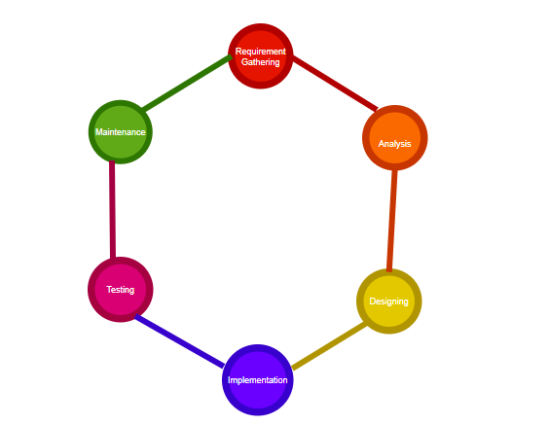

The Software Development Lifecycle refers to methodology with clearly defined processes for creating high-quality software. In details, the SDLC methodology focuses on the following phases of software development.

1. Requirement Gathering
2. Analysis
3. Designing
4. Implementation
5. Testing
6. Maintenance

**4) What is DFD? Create a DFD diagram on Flipkart.**

A data-flow diagram is a way of representing a flow of data through a process or a system. The DFD provides information about the outputs and inputs each entity and process itself. The flow of data of a system or a process is represented by DFD.A data flow diagram maps out the flow of information for any process or system. Also known as DFD are used to graphically represent the flow of data in a business information system.

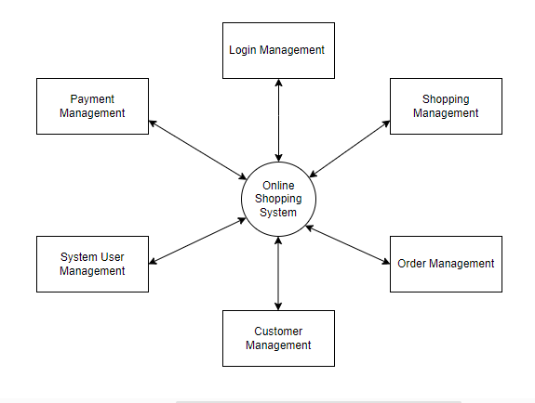

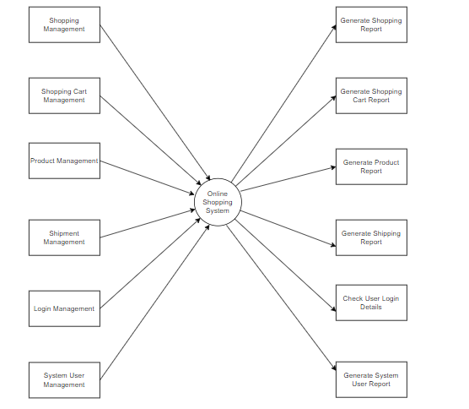

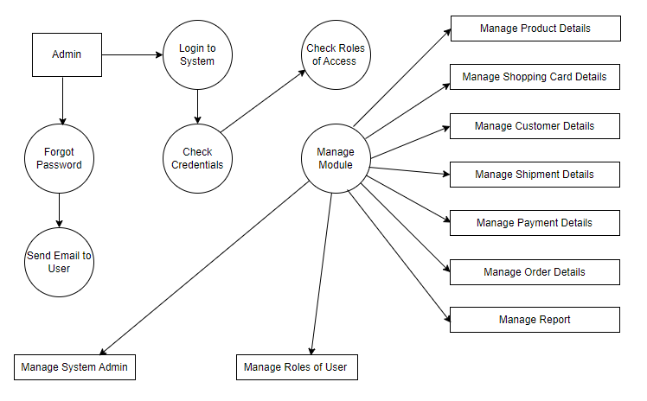

**5)What is Flow chart? Create flowchart to make addition of two numbers.**

A Flow chart is a diagram that shows the connection between different stages of a process or parts of a system. They are widely used in multiple fields to document, study, plan, improve and communicate processes in clear, easy-to-understand diagram. Flow chart diagram depicting a process, a system or a computer algorithm.

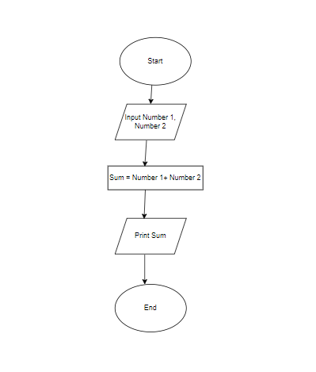

**6) What is Use case Diagram? Create a use-case on bill payment on Paytm.**

A Use case diagram is a graphical depiction of a user’s possible interaction with a system. A use case diagram shows various use cases and different types of users. These diagrams also identify the interactions between the system and its actors.

